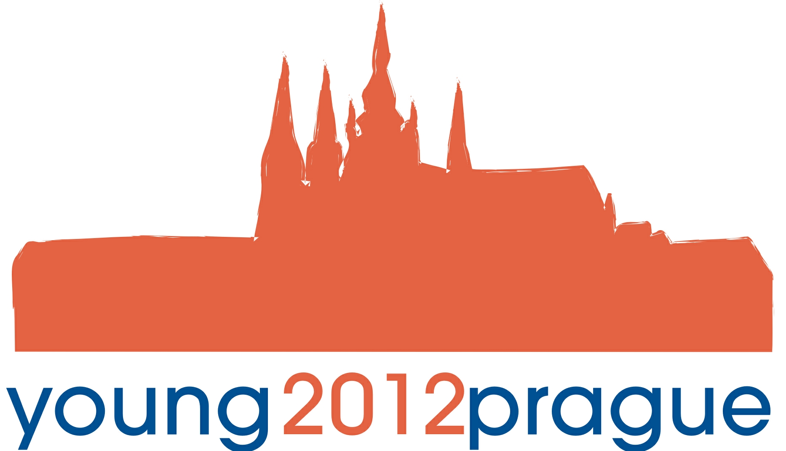

Mezinárodní festival pěveckých sborů a orchestrů mladých
International Festival of Young Choirs and Orchestras

Koncerty Concerts

Kostel sv. Mikuláše St. Nicholas Church
Staroměstské náměstí 27, Praha 1

Sobota 31. března 2012 Saturday 31st March 2012

11.00 Langley High School, Women´s Select Treble Choir
Mc Lean Virginia, USA
11.20 Packer Collegiate Choir, Brooklyn, New York, USA
11.40 Bullis School Choir, Potomac, Maryland, USA
12.00 Mixed Choir Stoevring, Denmark
12.20 Langley High School, Concert Choir
Mc Lean, Virginia, USA
13.20 Creative Arts Morgan Village Academy, Concert Choir
Camden, New Jersey, USA
13.40 Langley High School, Women´s Chamber Choir
Mc Lean, Virginia, USA
14.00 Wausau West High School Concert Chorale
Wausau, Wisconsin, USA
14.20 University of Puerto Rico Concert Choir
Puerto Rico
14.40 Langley High School, Madrigal Choir
Mc Lean, Virginia, USA

Vstup volný Admission free

