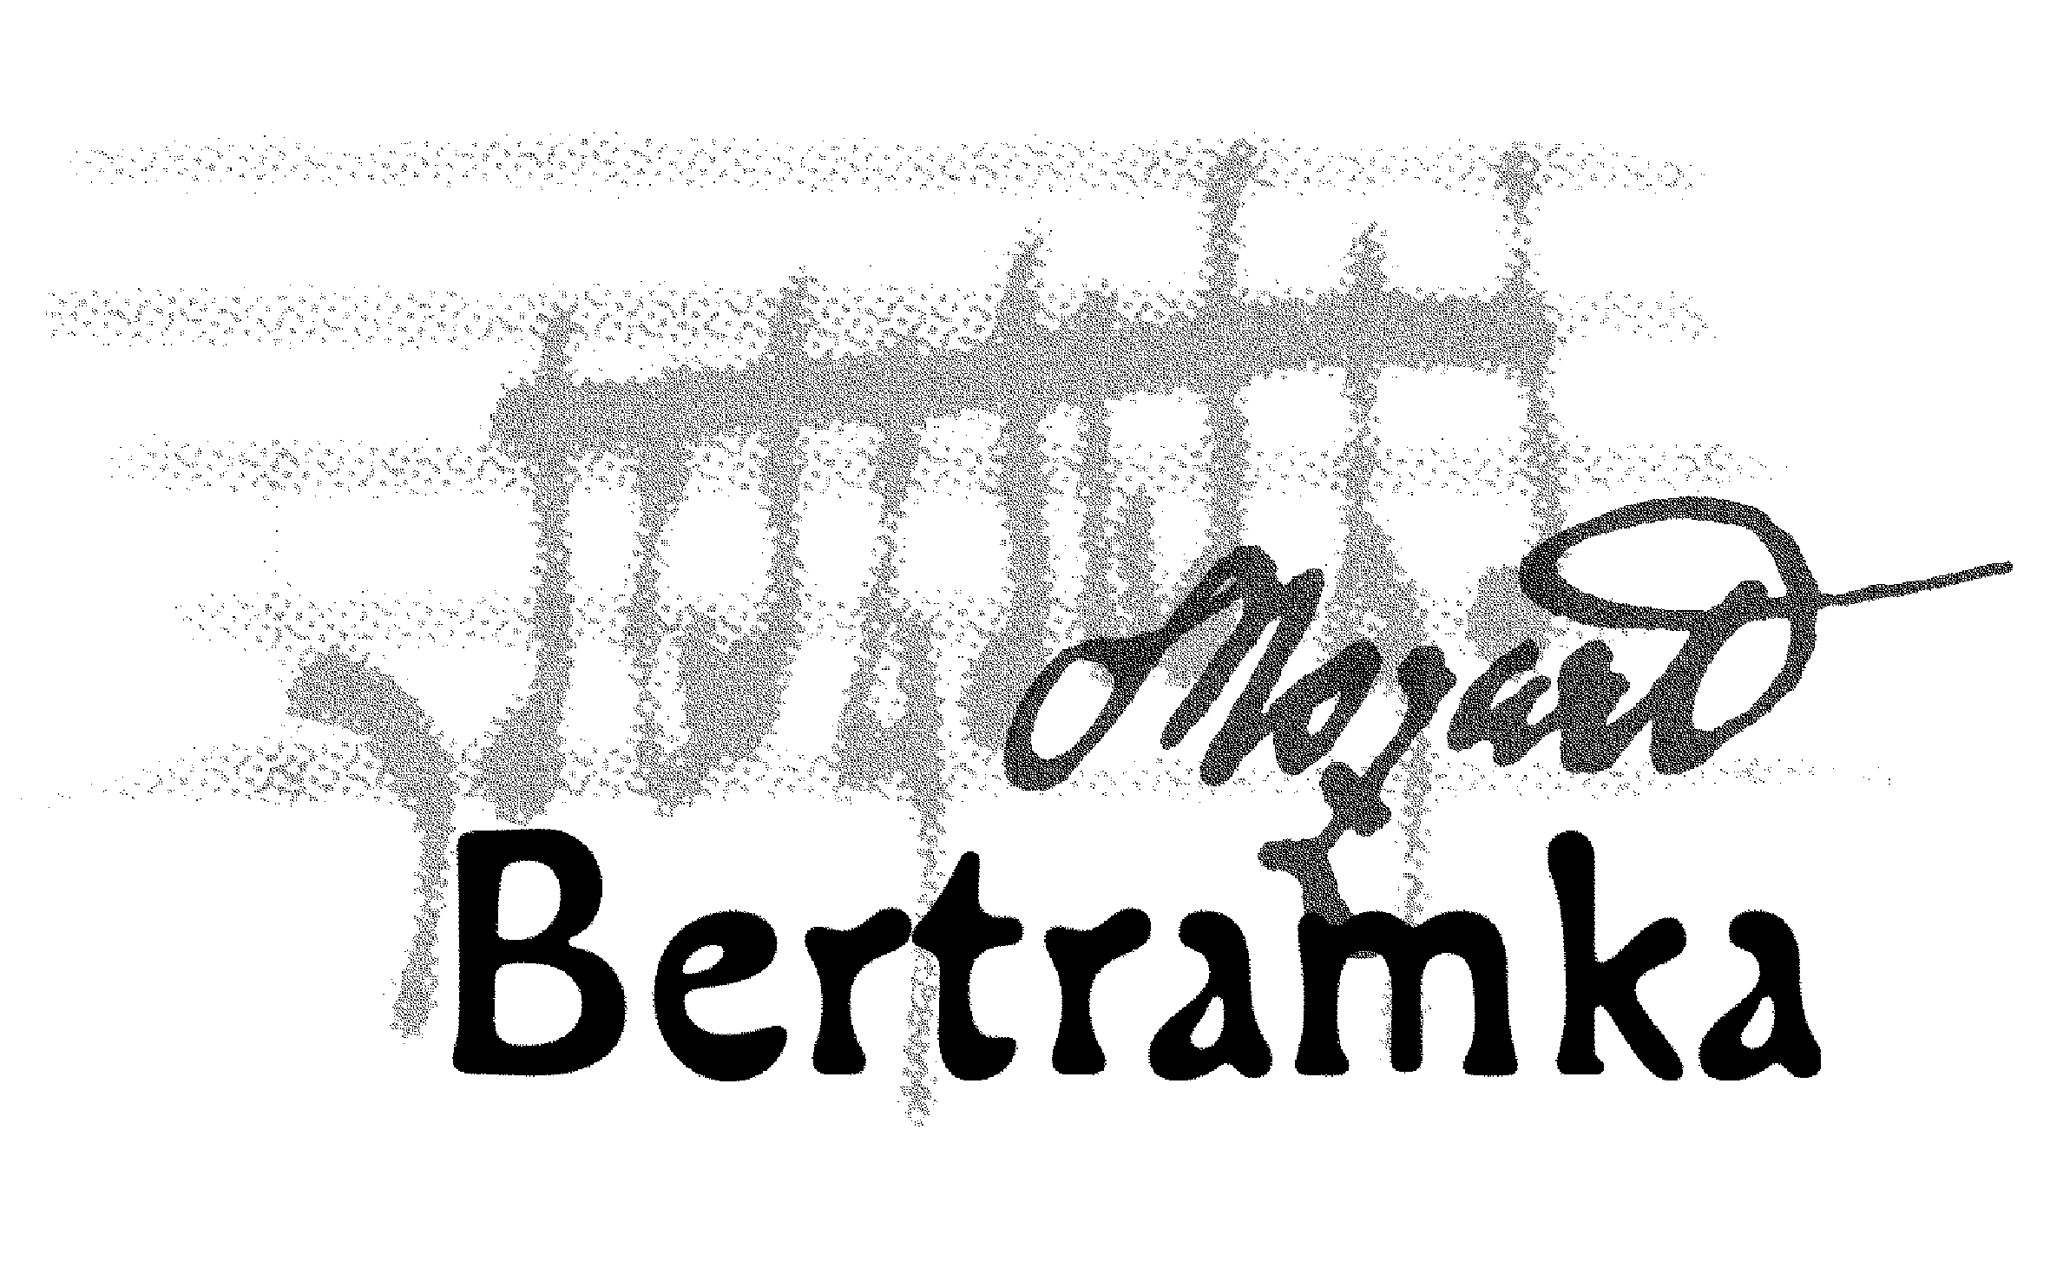
CONCERTS AT BERTRAMKA

OCTOBER 2007

Concerts begin at 5 p.m.

4.Th EUROART PRAGUE 2007 – Three Chamber Variations
Trio Concertino (violin, cello, piano),
Petr Ries – contrabass, Barbora Waldmannová – viola
W. A. Mozart: Piano Quartet in E flat major, K. 493
D. Šostakovič: Trio in E minor, Op. 67
F. Schubert: Forelenquintet

6.Sa Max Brod Trio (violin, cello, piano)
J. Haydn: Piano Trio in G, Hoboken XV: 25
W. A. Mozart: Piano Trio in B flat major, K. 502
L. van Beethoven: Piano Trio in E flat major, Op. 1/1

10.We Czech Trio (violin, cello, piano)

W. A. Mozart: Trio in B flat major, K. 254

J. Suk: Trio in C minor, Op. 2
A. Dvořák: Trio in B flat major, Op. 21

13.Sa Trio con Canto (soprano, clarinet, piano)
J. Kř. Vaňhal: Sonata No. 2 in E flat flat major for clarinet and piano
W. A. Mozart: Aria of Pamina from the opera Magic Flute for soprano and piano
W. A. Mozart: Aria of Countess from the opera Marriage of Figaro
for soprano and piano
Anonymous: Variation “L“ for Clarinet and Piano
W. A. Mozart: Aria of Sussanna from the opera Marriage of Figaro
for soprano and piano
W. A. Mozart: Aria of Donna Elvira from the opera Don Giovanni
for soprano and piano
J. Kř. Vaňhal: Sonata No. 1 in B flat major for clarinet and piano
W. A. Mozart: Aria „Parto! Ma tu ben mio“ from the opera La Clemenza di Tito
for soprano, clarinet and piano

17.We Thuri Trio (flute, oboe, English horn)
F. V. Kramář: Trio in F major
W. A. Mozart: The Magic Flute for two Instrumentes from an edition of 1792
L. van Beethoven: Trio in C major, Op. 87
J. Vent: Variation on theme from the opera „La Molinara“ (Giovanni Paisiello)
J. Vent: Trio No. 6 in C major
L. van Beethoven: Variations on „Lá ci darem la mano“ from Mozart’s
„Don Giovanni“, WoO. 28

20.Sa Trio Martinů (violin, cello, piano)
W. A. Mozart: Trio in C major, K. 548

J. Brahms: Trio in C minor, Op. 101
A. Dvořák: Dumky, Op. 90

24.We Kinský Trio Prague (violin, cello, piano)
W. A. Mozart: Trio in C major, K. 548
V. Novák: Trio in D minor “Quasi una ballata“, Op.27
A. Dvořák: “Dumky“, Op. 90

27.Sa M. Nostitz Trio (violin, viola, cello)
W. A. Mozart: Divertimento in E flat major, K. 563 for violin, viola and cello
L. van Beethoven: Serenade in D major, Op. 8 for violin, viola and cello

31.We ArteMiss Trio (violin, cello, piano)
J. Haydn: Trio all´Ongarese
J. Haydn: Duo for Violin and Cello
W. A. Mozart: Trio in C major No. 6, K. 548
L. van Beethoven: Trio No. 3, Op. 1

___________________________________________________________________________

BERTRAMKA – MUZEUM W. A. MOZARTA, Mozartova 169, Praha 5
Telefon: 257318461, 257317465, Tel/ fax: 257316753,
e-mail: mozart@bertramka.cz, www.bertramka.com

