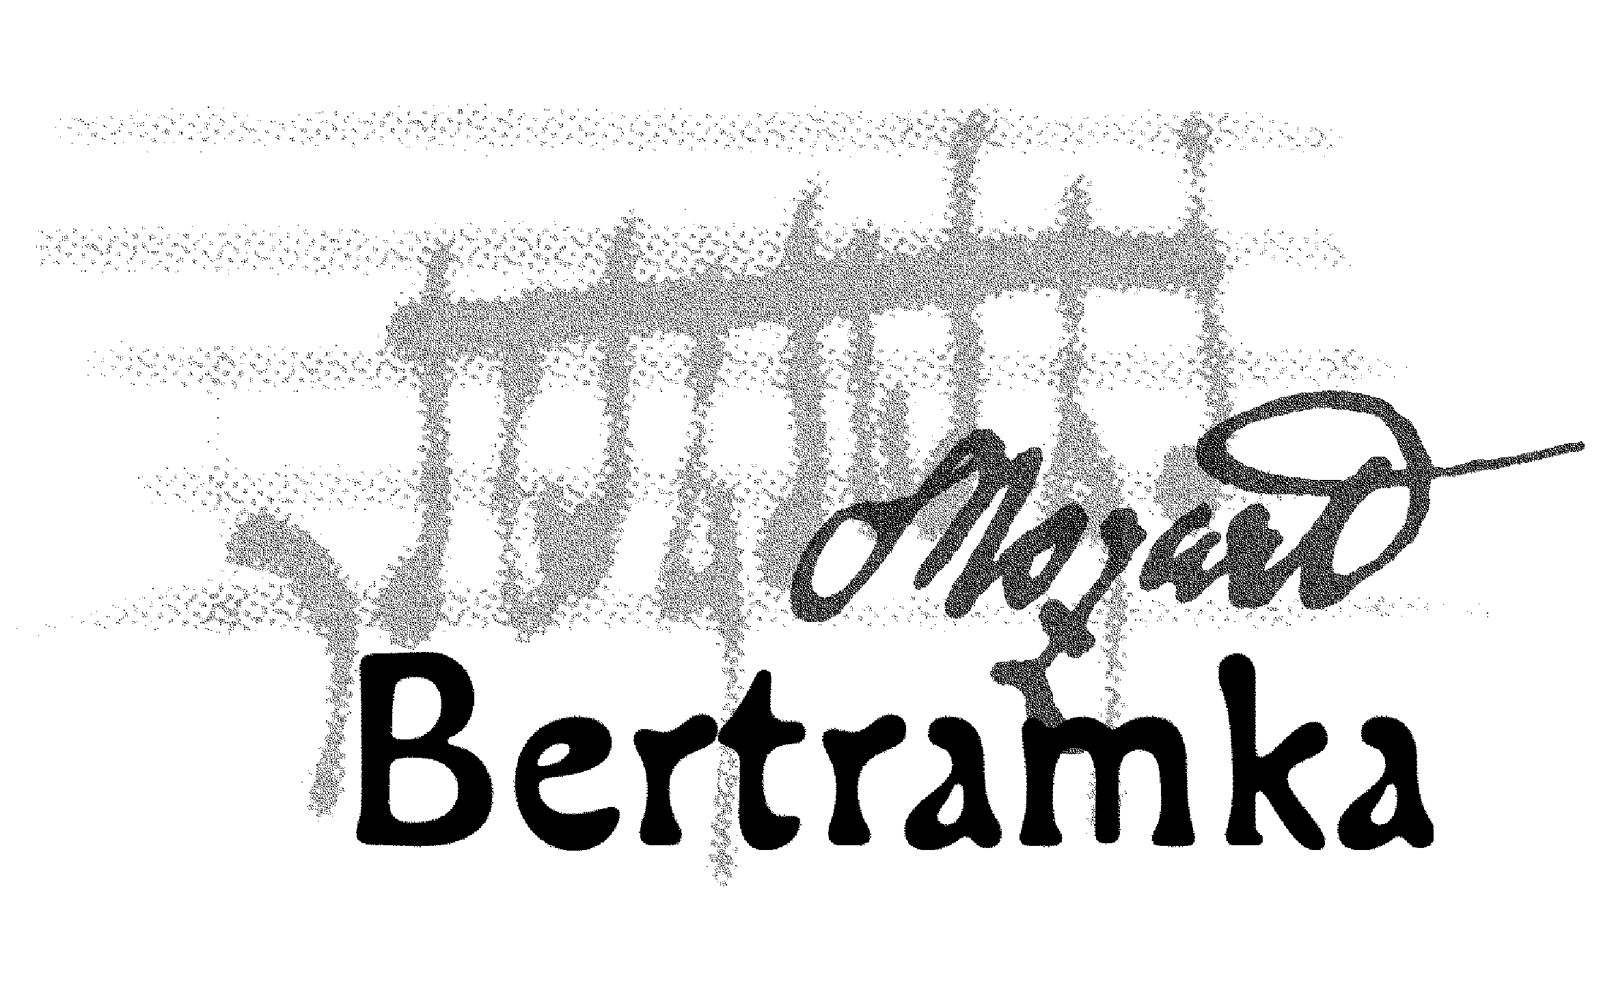
CONCERTS AT BERTRAMKA

SEPTEMBER 2007

Concerts begin at 5 p.m.

1.Sa Herold Quartet (violin, violin, viola, cello), Stanislav Gallin – piano
W. A. Mozart: String Quartet in D minor, K. 173
K. Janovický: String Quartet (2006) – PREMIERE
A. Dvořák: Piano Quintet in A major, Op. 81

5.We Jana Vonášková–Nováková – violin, Petr Novák – piano
W. A. Mozart: Sonata in E flat major for piano and violin, K. 481
L. Sluka: Consonanza con Mozart (2005)
K. Janovický: Sonata for violin and piano (2001)
V. Novák: Sonata for violin and piano (1891)

8.Sa Jan Thuri – oboe, Eduard Bayer – violin, Karel Doležal – viola,

Vladan Kočí – cello, Eri Gotoh – piano
J. Fiala: Quartet No.1 in E flat
J. Haydn: Sonata in D major, Hob. XVI/42 for piano solo
W. A. Mozart: Quartet in F for oboe, violin, viola and cello, K. 370
J. Ch. Bach: Quartet in B flat, Op. 8, No. 6
W. A. Mozart: Adagio for English horn, K. 580a

F. X. Thuri: „Views from the Windows of Bertramka“

12.We Markéta Mátlová – soprano, Stanislav Gallin – piano
W. A. Mozart: Un moto di gioja, K. 579
W. A. Mozart: Abendempfindung, K. 476
W. A. Mozart: Als Luise die Briefe…, K. 520
W. A. Mozart: Sonata in A major, K. 331
W. A. Mozart: Aria of Sextus from the opera La clemenza di Tito
F. Schubert: An die Musik
F. Schubert: Der Tod und das Mädchen
F. Schubert: Erlkönig
P. I. Čajkovskij: Lied der Zigeunerin
P. I. Čajkovskij: Wiegenlied
P. I. Čajkovskij: So bald vergessen
A. Dvořák: Gipsy Melodies (selection)

15.Sa Barbora Veisová – viola, Jan Pařík – clarinet, Jan Dušek – piano
R. Schumann: Fairy Tales, Op. 132
W. A. Mozart: Trio No. 4 in E flat major, K. 498 „Kegelstatt“ Trio
M. Bruch: Eight Pieces, Op. 83

19.We Marie Mátlová – violin, Ondřej Valenta – cello, Lukáš Klánský – piano
J. Haydn: Trio No.1 in G major
W. A. Mozart: Piano Trio in B flat major, K. 502
L.van Beethoven: Trio III, Op. 1, No. 3, in C minor

22.Sa Bennewitz Quartet (violin, violin, viola, cello)
W. A. Mozart: Quartet in G major, K. 80 “Lodi“
J. Haydn: Quartet in C major, Op. 20/2
L. Janáček: Quartet No. 2 “Intimate Letters“

26.We Monika Vrabcová – violin, Kateřina Pirochová – piano
W. A. Mozart: Sonata in B flat major for violin and piano, K. 378
E. Chausson: Poéme, Op. 25
R. Strauss: Sonata in E flat major for violin and piano

29.Sa Members of Vlach Quartet: Jana Vlachová – violin, Karel Stadtherr – viola,
Mikael Ericsson – cello and Jan Souček – oboe
F. Schubert: String Trio in B flat major
W. A. Mozart: Quartet in F major for oboe, violin, viola and cello, K. 370
L. van Beethoven: String Trio in G major, Op. 8 „Serenade“

___________________________________________________________________________

BERTRAMKA – MUZEUM W. A. MOZARTA, Mozartova 169, Praha 5
Telefon: 257318461, 257317465, Tel/ fax: 257316753,
e-mail: mozart@bertramka.cz, www.bertramka.com

